Services and Networking

What is Networking?
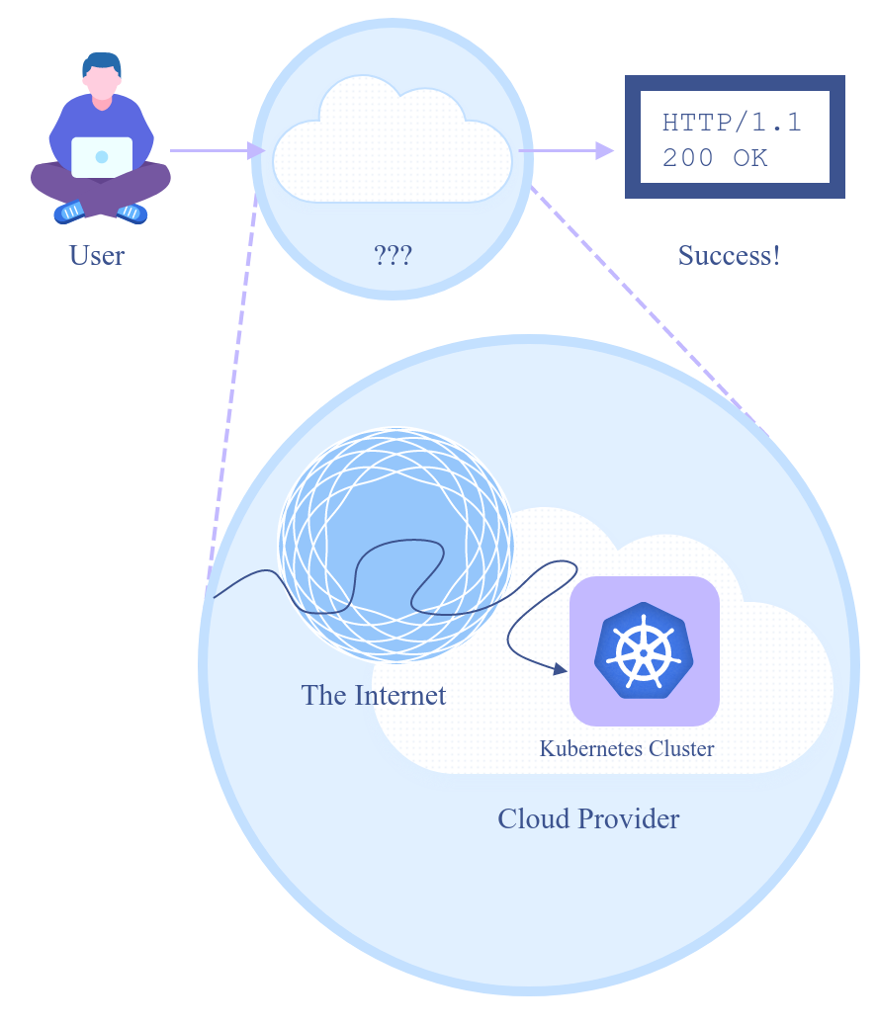
Simply put, Networking is when one computer can talk to another. This communication happens in many diverse ways but you can think of it like a FedEx delivery.

Essentially all devices connected to the internet have an IP address, which is like your house address.

All devices also have their own MAC address, which is the like name of the home owner.

Sending a package to another person is considered creating “traffic” over the internet. Packages or packets in networking, traverse internet traffic to send data to your chosen destination. The packet will have your IP address and MAC address, the same way a FedEx package would have your name and home address.

Networking includes all of the protocols or rules used on the internet to communicate from point a to point b. Some of those protocols regulate services like DNS, HTTP, or HTTPS traffic.

The OSI Model
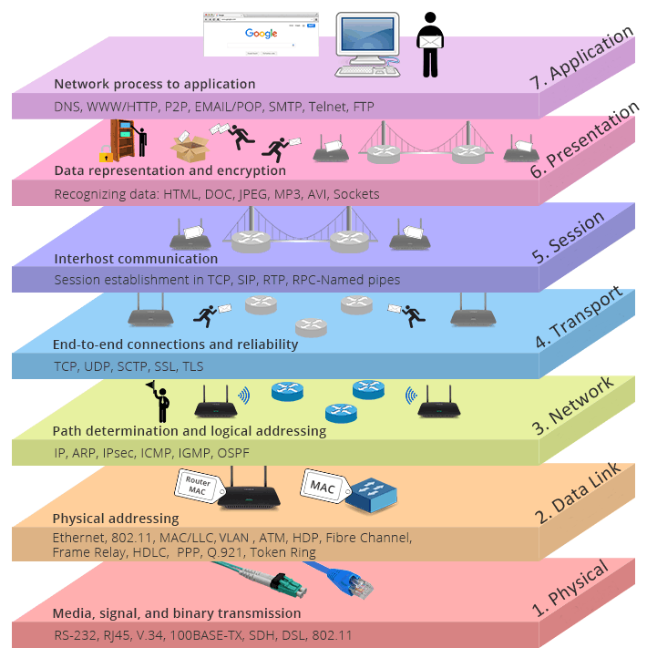

What is Networking in Kubernetes?

Everything in Kubernetes is an API call, served by the Kubernetes API server. This presents 4 distinct networking challenges:

1. How to enable container-to-container communications
2. Pod-to-Pod communications.
3. Pod-to-Service communications.
4. External-to-Service communications.

Container to Container Communications

